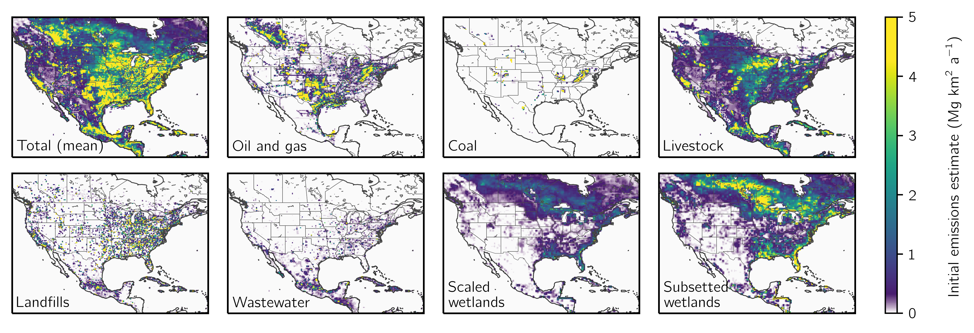

**Figure 1:** Prior estimates for 2019 mean methane emissions of oil and gas, coal, livestock, landfills, wastewater, and wetlands on the 0.25° ⨉ 0.3125° GEOS-Chem grid used for the inversion. Wetland emissions are shown for the two estimates used in the ensemble. The total emissions include the mean of these two wetland emissions estimates.

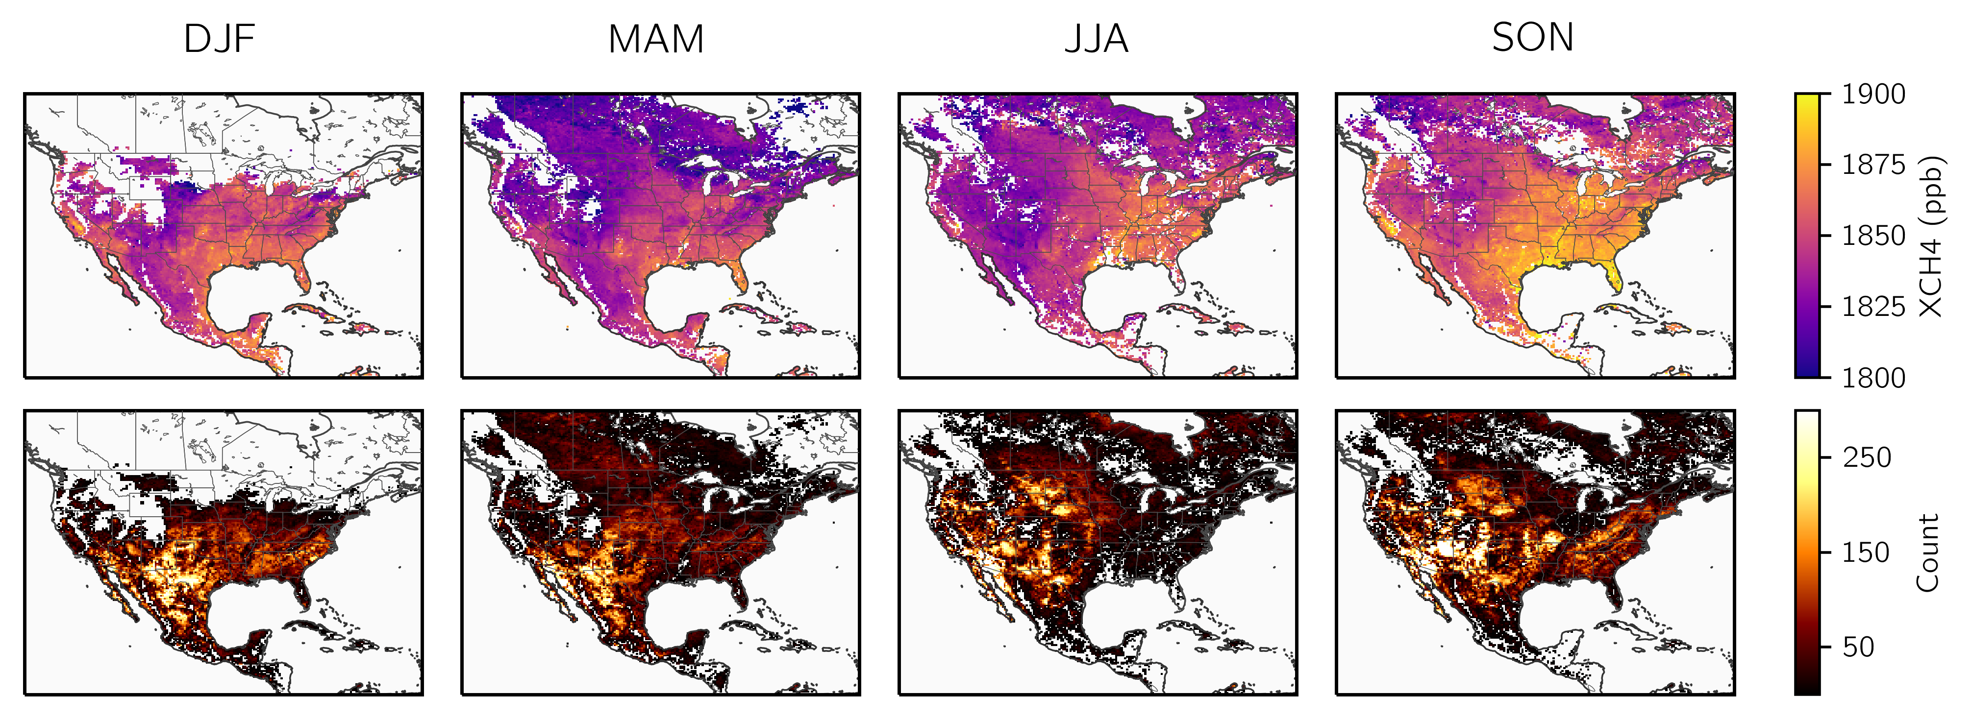

**Figure 2:** Seasonal average column methane concentrations (top) and observation counts (bottom) from TROPOMI averaged on the 0.25° ⨉ 0.3125° GEOS-Chem grid used for the inversion. The observations here do not include scenes with albedo less than 0.05 or snow- or ice-cover, as defined by an empirical parameter derived from albedo measured in the shortwave and near infrared and by excluding scenes north of 50° in winter (DJF).

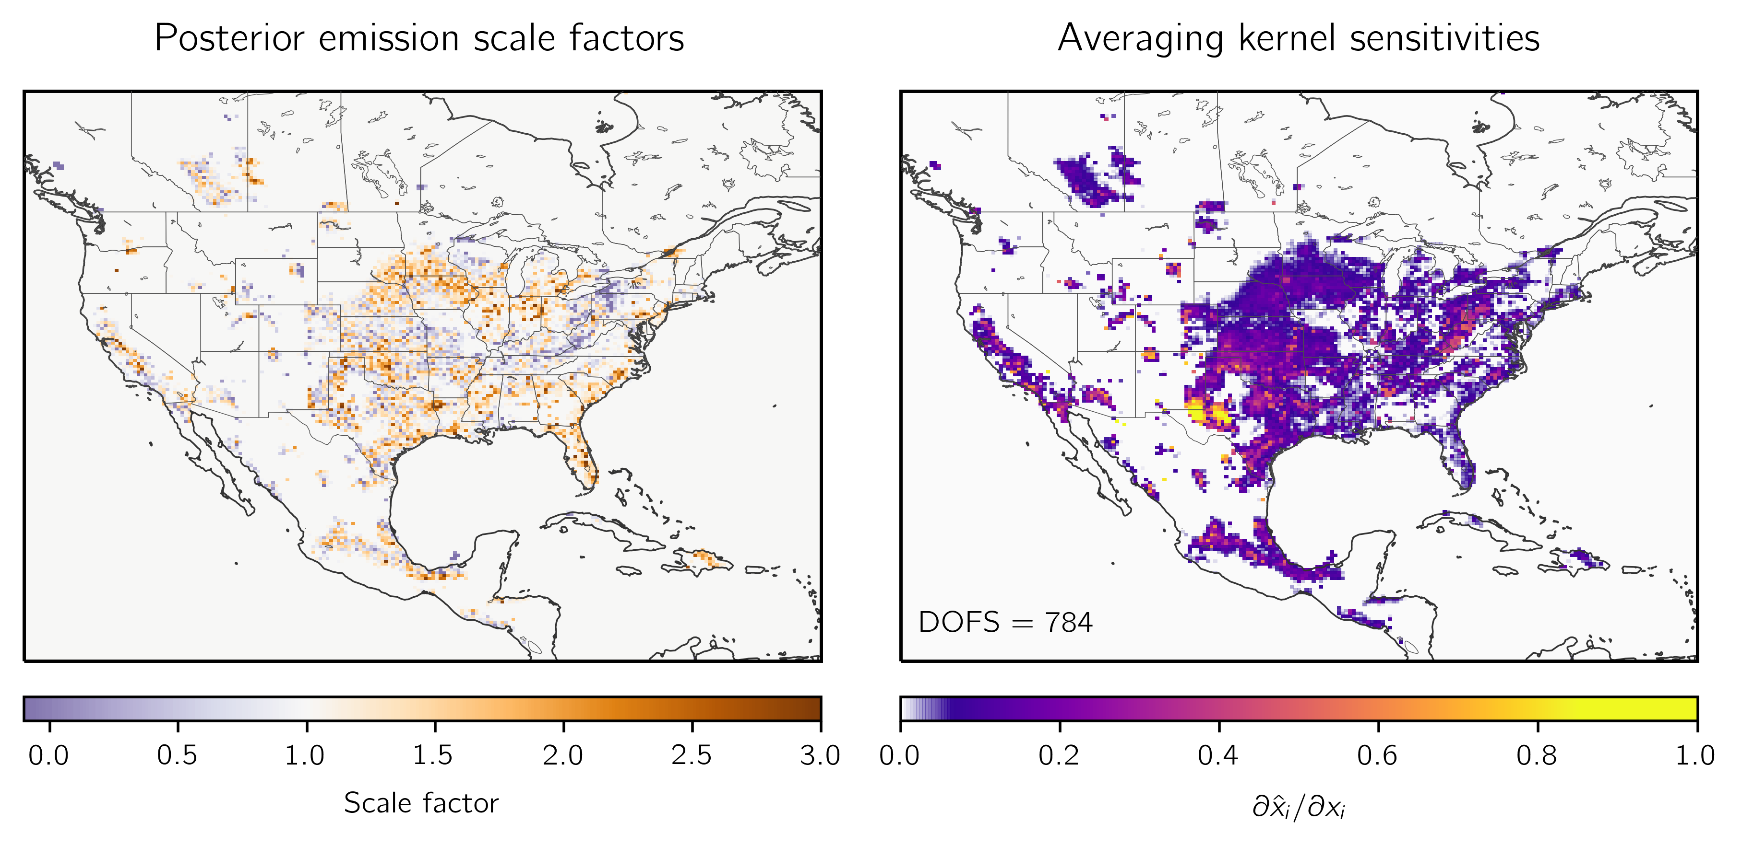

**Figure 3:** The ensemble mean posterior emissions estimates (left) expressed as scale factors relative to the prior emissions estimate and the associated information content as defined by the ensemble mean averaging kernel sensitivities (the diagonal elements of the averaging kernel matrix; right). The mean degrees of freedom for signal (DOFS), defined as the sum of the mean averaging kernel sensitivities, are inset.

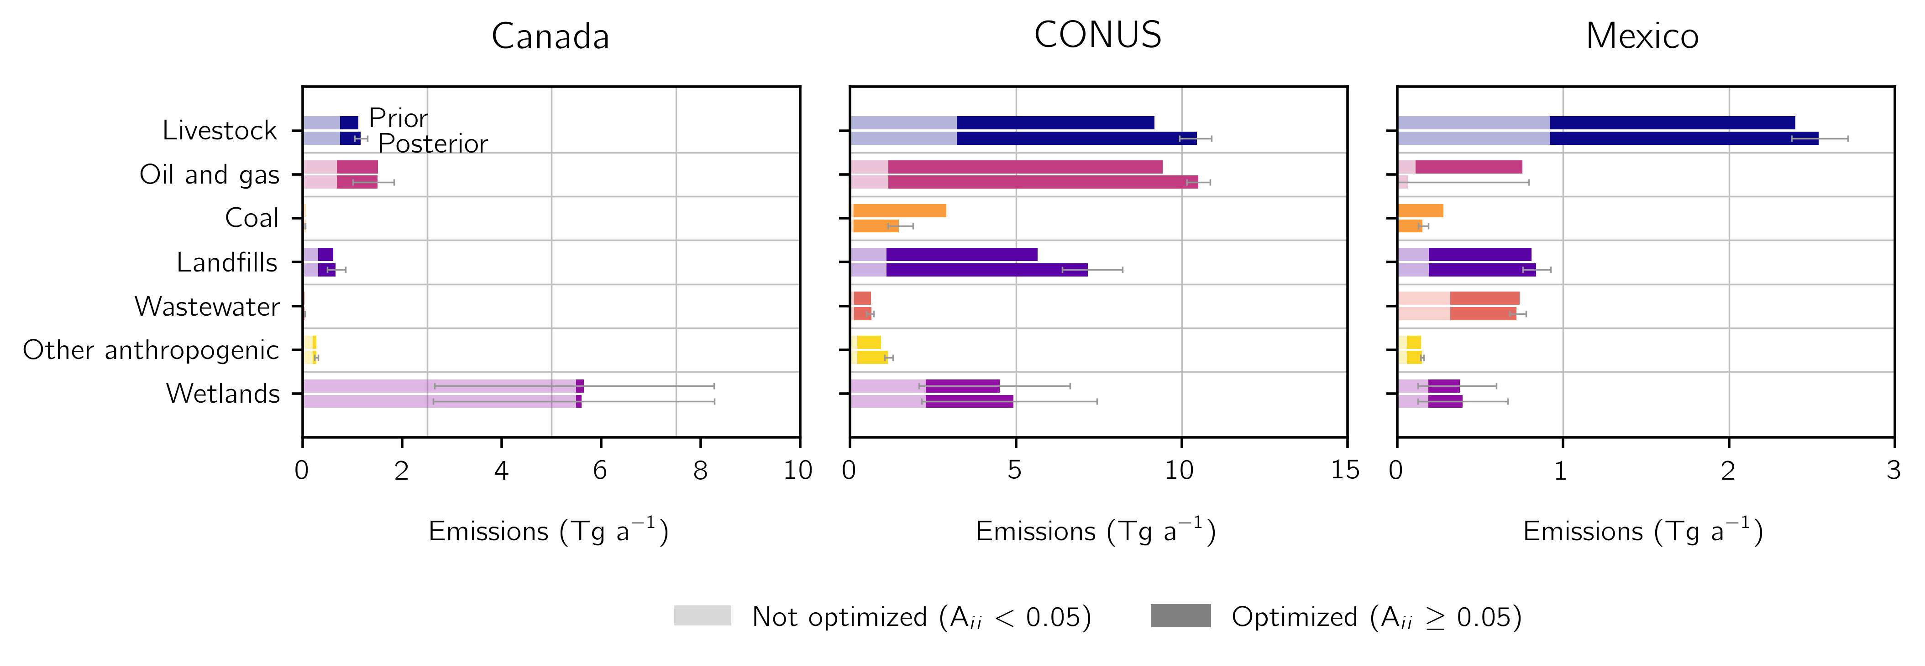

**Figure 4:** Optimized sectoral methane emissions for Canada (left), the contiguous United States (CONUS; center), and Mexico (right). National prior (top bar) and mean posterior (bottom bar) sectoral emissions totals are shown for livestock, oil and gas, coal, landfills, wastewater, other anthropogenic emissions, and wetlands. The light shading corresponds to the mean sectoral emissions left unoptimized by the inversion, defined by the mean emissions in grid cells with averaging kernel sensitivities less than 0.05. The bars with dark shading show the mean emissions in grid cells optimized by the inversion. Error bars on the posterior emissions are given by the inversion ensemble spread. Error bars on the prior wetland emissions reflect the range of initial estimates given by the subsetted and scaled wetland priors.

**Figure 5:** Optimized anthropogenic methane emissions for the 48 contiguous United States (CONUS). The center panel shows the prior (left bar) and mean posterior (right bar) anthropogenic methane emissions, including livestock, oil and natural gas, coal, landfill, wastewater, and other sources, ranked from largest (left) to smallest (right) posterior emissions. The information content as defined by the mean reduced-form averaging kernel sensitivities (the diagonal elements of the reduced-form averaging kernel matrix) is shown in the bottom panel. In both cases, the error bars give the spread of the inversion ensemble. The top panel shows the cumulative fraction of CONUS emissions explained by the states.

**Figure 6:** Optimized anthropogenic methane emissions for the largest 15 metropolitan statistical areas in the contiguous United States as ranked by population. Metropolitan statistical area extents are given by the U.S. Census Bureau. We show urban prior (top bar) and mean posterior (bottom bar) anthropogenic total emissions (left panel) and per capita emissions (center panel) together with the information content, defined by the mean reduced-form averaging kernel sensitivities (the diagonal elements of the reduced-form averaging kernel matrix). Prior emissions are divided into contributions from landfills, wastewater, oil and natural gas, coal, livestock, and other. We do not separate the posterior emissions because source colocation within urban areas produces large sectoral covariances. Error bars represent the ensemble spread.

**Figure 7:** Livestock (TBD)

|  |  |  |  |  |  |  |  |
| --- | --- | --- | --- | --- | --- | --- | --- |
| **Base inversions**[1] | | | **Inversion parameters**[2] | | **Inversion evaluation**[3] | | |
| **Wetland inventory**[4] | **Optimized boundary conditions**[5] | **Latitude correction**[6] | **Regularization factor**[7] | **Prior error standard deviation**[8] | **J**A**(x̂)/n**f[9] | **Percentage of negative values**[10] | **Optimized grid cells**[11] |
| Scaled | Yes | Yes | 0.3 | 0.75 | 1 | 4.5 | 4655 |
| 0.5 | 1 | 1 | 9.6 | 5490 |
| Scaled | Yes | No | 0.25 | 0.75 | 1 | 4.5 | 4467 |
| 0.4 | 1 | 1 | 9.4 | 5353 |
| Scaled | No | Yes | 0.15 | 0.5 | 1 | 1.5 | 2592 |
| 0.25 | 0.75 | 1 | 5.3 | 4468 |
| Scaled | No | No | 0.15 | 0.75 | 1 | 5.6 | 3872 |
| Subsetted | Yes | Yes | 0.2 | 0.5 | 1 | 1.5 | 3692 |
| 0.45 | 0.75 | 1 | 5.5 | 5661 |
| Subsetted | Yes | No | 0.175 | 0.5 | 1 | 1.6 | 3435 |
| 0.3 | 0.75 | 1 | 4.9 | 5327 |
| 0.5 | 1 | 1 | 9.4 | 6067 |
| Subsetted | No | Yes | 0.175 | 0.5 | 1 | 1.8 | 3443 |
| 0.35 | 0.75 | 1 | 5.9 | 5476 |
| Subsetted | No | No | 0.175 | 0.75 | 1 | 6.2 | 4759 |

**Table 1:** The 15 members of the inversion ensemble.

|  |  |  |  |
| --- | --- | --- | --- |
| **Boundary condition element**[12] | **Boundary condition correction (ppb)**[13] | | |
| **Mean**[14] | **Minimum** | **Maximum** |
| North | -4.97 | -7.02 | -2.53 |
| South | 10.4 | 6.35 | 14.24 |
| East | -12.55 | -18.12 | -6.41 |
| West | -0.65 | -1.51 | 0.09 |

**Table 2:** The statistics of the corrections for the 9 inversion ensemble members that optimize the boundary condition. All averaging kernel sensitivity values are greater than 0.99 and are consequently not shown here.

|  |  |  |  |  |
| --- | --- | --- | --- | --- |
|  | **Prior**[15] | **Posterior**[16] | **Averaging kernel sensitivity**[17] | **Percentage of prior emissions optimized**[18] |
| **Total sources [Tg a-1]** | 34.3 (31.9 - 36.4) | 37.5 (33.4 - 40.3) |  | 74 (60 - 83) |
| **Anthropogenic sources** | 28.7 | 31.4 (30.0 - 33.0) |  | 79 (65 - 87) |
| Livestock | 9.2 | 10.5 (9.9 - 10.9) | 0.67 (0.50 - 0.77) | 65 (45 - 76) |
| Oil and natural gas | 9.4 | 10.5 (10.1 - 10.9) | 0.92 (0.88 - 0.95) | 88 (80 - 92) |
| Coal | 2.9 | 1.5 (1.1 - 1.9) | 0.62 (0.42 - 0.80) | 96 (94 - 98) |
| Landfills | 5.7 | 7.2 (6.4 - 8.2) | 0.49 (0.31 - 0.66) | 81 (62 - 90) |
| Wastewater | 0.6 | 0.6 (0.5 - 0.7) | 0.35 (0.15 - 0.60) | 80 (58 - 90) |
| Other anthropogenic | 0.9 | 1.1 (1.0 - 1.3) | 0.60 (0.36 - 0.76) | 78 (53 - 89) |
| **Natural sources** | 5.6 | 6.1 (3.3 - 8.6) |  | 43 (15 - 69) |
| Wetlands | 4.5 (2.1 - 6.6) | 4.9 (2.2 - 7.4) | 0.22 (0.00 - 0.55) | 49 (5 - 105) |
| Other biogenic | 1.1 | 1.2 (1.2 - 1.2) | 0.26 (0.16 - 0.32) | 40 (24 - 50) |

**Table 3:** Prior and posterior emissions and information content for the contiguous United States (CONUS).

|  |  |  |  |  |  |  |  |  |  |  |  |  |  |  |  |
| --- | --- | --- | --- | --- | --- | --- | --- | --- | --- | --- | --- | --- | --- | --- | --- |
| **Emissions**  **(Gg a-1)**[19] | **Livestock** | | **Oil & natural gas** | | **Coal** | | **Landfills** | | **Wastewater** | | **Other anthropogenic** | | **Total anthropogenic** | | |
| **State**[20] | **x**A[21] | **x̂**[22] | **x**A | **x̂** | **x**A | **x̂** | **x**A | **x̂** | **x**A | **x̂** | **x**A | **x̂** | **x**A | **x̂**[23] | **Sensitivity**[24] |
| 1. Texas | 977 | 1174 | 3546 | 4326 | 17 | 24 | 480 | 643 | 44 | 49 | 85 | 115 | 5150 | 6332 (6101, 6528) | 0.94 (0.89, 0.97) |
| 2. California | 877 | 1100 | 191 | 230 | 0 | 0 | 508 | 514 | 51 | 58 | 138 | 149 | 1764 | 2051 (1944, 2124) | 0.86 (0.75, 0.93) |
| 3. Oklahoma | 333 | 398 | 636 | 899 | 13 | 21 | 108 | 122 | 3 | 3 | 6 | 6 | 1099 | 1449 (1384, 1516) | 0.86 (0.75, 0.92) |
| 4. Pennsylvania | 165 | 198 | 409 | 230 | 461 | 525 | 131 | 205 | 16 | 21 | 16 | 21 | 1197 | 1200 (1042, 1388) | 0.57 (0.35, 0.77) |
| 5. Louisiana | 63 | 83 | 431 | 765 | 2 | 2 | 104 | 138 | 7 | 9 | 114 | 191 | 721 | 1188 (1010, 1415) | 0.55 (0.28, 0.76) |
| 6. New Mexico | 213 | 209 | 946 | 928 | 39 | 31 | 64 | -37 | 2 | 2 | 4 | 3 | 1267 | 1135 (1100, 1180) | 0.96 (0.93, 0.98) |
| 7. Iowa | 621 | 794 | 37 | 59 | 0 | 0 | 72 | 117 | 8 | 13 | 5 | 7 | 743 | 991 (943, 1017) | 0.75 (0.54, 0.88) |
| 8. Florida | 164 | 252 | 18 | 25 | 0 | 0 | 297 | 612 | 11 | 17 | 30 | 47 | 521 | 953 (634, 1377) | 0.32 (0.04, 0.58) |
| 9. Illinois | 153 | 195 | 87 | 123 | 209 | 163 | 237 | 380 | 28 | 38 | 17 | 21 | 731 | 919 (862, 971) | 0.55 (0.29, 0.79) |
| 10. Kansas | 440 | 449 | 338 | 359 | 0 | 0 | 84 | 39 | 11 | 9 | 4 | 3 | 878 | 859 (839, 888) | 0.80 (0.66, 0.89) |

**Table 4:** Prior and posterior sectoral emissions and information content for the top 10 methane producing states in the contiguous United States as ranked by posterior emissions.

**Table 5:** Top 15 cities

|  |  |  |  |  |  |  |  |  |  |  |  |  |  |  |  |
| --- | --- | --- | --- | --- | --- | --- | --- | --- | --- | --- | --- | --- | --- | --- | --- |
| **Emissions**  **(Gg a-1)** | **Livestock** | | **Oil & natural gas** | | **Coal** | | **Landfills** | | **Wastewater** | | **Other anthropogenic** | | **Total anthropogenic** | | |
| **State** | **x**A | **x̂** | **x**A | **x̂** | **x**A | **x̂** | **x**A | **x̂** | **x**A | **x̂** | **x**A | **x̂** | **x**A | **x̂** | **Sensitivity** |
| 1. Texas | 977 | 1174 | 3546 | 4326 | 17 | 24 | 480 | 643 | 44 | 49 | 85 | 115 | 5150 | 6332 (6101, 6528) | 0.94 (0.89, 0.97) |
| 2. California | 877 | 1100 | 191 | 230 | 0 | 0 | 508 | 514 | 51 | 58 | 138 | 149 | 1764 | 2051 (1944, 2124) | 0.86 (0.75, 0.93) |
| 3. Oklahoma | 333 | 398 | 636 | 899 | 13 | 21 | 108 | 122 | 3 | 3 | 6 | 6 | 1099 | 1449 (1384, 1516) | 0.86 (0.75, 0.92) |
| 4. Pennsylvania | 165 | 198 | 409 | 230 | 461 | 525 | 131 | 205 | 16 | 21 | 16 | 21 | 1197 | 1200 (1042, 1388) | 0.57 (0.35, 0.77) |
| 5. Louisiana | 63 | 83 | 431 | 765 | 2 | 2 | 104 | 138 | 7 | 9 | 114 | 191 | 721 | 1188 (1010, 1415) | 0.55 (0.28, 0.76) |
| 6. New Mexico | 213 | 209 | 946 | 928 | 39 | 31 | 64 | -37 | 2 | 2 | 4 | 3 | 1267 | 1135 (1100, 1180) | 0.96 (0.93, 0.98) |
| 7. Iowa | 621 | 794 | 37 | 59 | 0 | 0 | 72 | 117 | 8 | 13 | 5 | 7 | 743 | 991 (943, 1017) | 0.75 (0.54, 0.88) |
| 8. Florida | 164 | 252 | 18 | 25 | 0 | 0 | 297 | 612 | 11 | 17 | 30 | 47 | 521 | 953 (634, 1377) | 0.32 (0.04, 0.58) |
| 9. Illinois | 153 | 195 | 87 | 123 | 209 | 163 | 237 | 380 | 28 | 38 | 17 | 21 | 731 | 919 (862, 971) | 0.55 (0.29, 0.79) |
| 10. Kansas | 440 | 449 | 338 | 359 | 0 | 0 | 84 | 39 | 11 | 9 | 4 | 3 | 878 | 859 (839, 888) | 0.80 (0.66, 0.89) |
| 11. Colorado | 255 | 232 | 376 | 353 | 176 | 102 | 113 | 112 | 4 | 4 | 6 | 5 | 930 | 809 (740, 861) | 0.59 (0.44, 0.72) |
| 12. Michigan | 160 | 191 | 113 | 133 | 0 | 0 | 268 | 405 | 11 | 20 | 16 | 23 | 568 | 773 (674, 906) | 0.49 (0.16, 0.74) |
| 13. Alabama | 102 | 109 | 113 | 121 | 165 | 155 | 238 | 266 | 21 | 25 | 10 | 11 | 649 | 686 (629, 740) | 0.75 (0.55, 0.89) |
| 14. North Carolina | 252 | 390 | 24 | 23 | 0 | 0 | 183 | 229 | 123 | 17 | 11 | 13 | 593 | 672 (547, 766) | 0.48 (0.24, 0.71) |
| 15. Indiana | 127 | 173 | 45 | 61 | 82 | 78 | 163 | 281 | 10 | 17 | 11 | 16 | 438 | 626 (550, 693) | 0.54 (0.28, 0.74) |
| 16. Ohio | 143 | 147 | 195 | 158 | 94 | 29 | 252 | 243 | 22 | 24 | 16 | 16 | 723 | 617 (577, 673) | 0.63 (0.38, 0.82) |
| 17. Nebraska | 480 | 539 | 22 | 25 | 0 | 0 | 41 | 45 | 5 | 5 | 3 | 3 | 551 | 617 (604, 629) | 0.64 (0.48, 0.73) |
| 18. Arkansas | 124 | 122 | 105 | 134 | 9 | 14 | 93 | 107 | 8 | 10 | 189 | 222 | 527 | 610 (566, 646) | 0.74 (0.48, 0.86) |
| 19. Georgia | 109 | 128 | 32 | 49 | 0 | 0 | 218 | 400 | 5 | 9 | 12 | 19 | 376 | 605 (500, 731) | 0.58 (0.35, 0.73) |
| 20. West Virginia | 31 | 26 | 240 | 179 | 816 | 343 | 49 | 31 | 2 | 2 | 6 | 4 | 1143 | 585 (485, 730) | 0.66 (0.46, 0.83) |
| 21. Wisconsin | 380 | 414 | 15 | 17 | 0 | 0 | 103 | 121 | 9 | 8 | 13 | 15 | 519 | 575 (518, 629) | 0.47 (0.07, 0.70) |
| 22. Idaho | 319 | 316 | 10 | 11 | 0 | 0 | 165 | 221 | 1 | 2 | 3 | 3 | 499 | 552 (483, 619) | 0.63 (0.49, 0.76) |
| 23. Minnesota | 291 | 394 | 30 | 24 | 0 | 0 | 76 | 83 | 4 | 4 | 9 | 10 | 410 | 515 (459, 567) | 0.53 (0.13, 0.69) |
| 24. Mississippi | 86 | 104 | 97 | 135 | 3 | 6 | 87 | 141 | 16 | 24 | 17 | 23 | 307 | 434 (380, 503) | 0.53 (0.22, 0.75) |
| 25. New York | 170 | 146 | 84 | 50 | 0 | 0 | 140 | 165 | 35 | 46 | 19 | 24 | 448 | 431 (352, 536) | 0.30 (0.06, 0.50) |

**Table S1:** Prior and posterior sectoral emissions and information content for the largest 25 methane producing states in the contiguous United States as ranked by posterior emissions.

[I won’t add footnotes to the supplemental table until edits area finished on Table 5; I assume I can use the same text in the supplement?]

|  |  |  |  |  |  |  |  |  |  |  |  |  |  |  |  |
| --- | --- | --- | --- | --- | --- | --- | --- | --- | --- | --- | --- | --- | --- | --- | --- |
| **Emissions (Gg a-1)** | **Livestock** | | **Oil & natural gas** | | **Coal** | | **Landfills** | | **Wastewater** | | **Other anthropogenic** | | **Total anthropogenic** | | |
| **State** | **x**A | **x̂** | **x**A | **x̂** | **x**A | **x̂** | **x**A | **x̂** | **x**A | **x̂** | **x**A | **x̂** | **x**A | **x̂** | **Sensitivity** |
| 26. South Dakota | 292 | 351 | 9 | 13 | 0 | 0 | 13 | 19 | 5 | 12 | 2 | 3 | 322 | 397 (363, 417) | 0.38 (0.11, 0.53) |
| 27. Kentucky | 152 | 143 | 92 | 67 | 202 | 62 | 108 | 103 | 4 | 4 | 7 | 7 | 566 | 385 (336, 449) | 0.64 (0.40, 0.82) |
| 28. Virginia | 112 | 109 | 61 | 31 | 172 | 15 | 171 | 174 | 23 | 23 | 12 | 11 | 550 | 363 (299, 428) | 0.56 (0.35, 0.75) |
| 29. Missouri | 292 | 263 | 16 | 13 | 0 | 0 | 82 | 51 | 10 | 8 | 39 | 23 | 439 | 359 (328, 394) | 0.55 (0.29, 0.69) |
| 30. Tennessee | 136 | 122 | 38 | 40 | 3 | 2 | 156 | 130 | 23 | 20 | 8 | 8 | 364 | 321 (292, 349) | 0.60 (0.33, 0.77) |
| 31. Montana | 212 | 211 | 70 | 63 | 20 | 10 | 19 | 19 | 1 | 1 | 3 | 3 | 323 | 306 (292, 322) | 0.31 (0.22, 0.40) |
| 32. North Dakota | 123 | 124 | 137 | 145 | 6 | 6 | 25 | 26 | 2 | 2 | 2 | 2 | 294 | 304 (286, 320) | 0.59 (0.41, 0.70) |
| 33. Washington | 143 | 151 | 20 | 20 | 0 | 0 | 84 | 100 | 13 | 14 | 13 | 13 | 273 | 299 (268, 353) | 0.10 (0.04, 0.14) |
| 34. Utah | 102 | 106 | 134 | 46 | 119 | 76 | 51 | 50 | 0 | 0 | 3 | 3 | 408 | 280 (248, 336) | 0.74 (0.57, 0.87) |
| 35. Oregon | 126 | 133 | 18 | 23 | 0 | 0 | 87 | 113 | 2 | 3 | 8 | 8 | 241 | 279 (256, 319) | 0.08 (0.05, 0.11) |
| 36. Arizona | 142 | 142 | 41 | 41 | 2 | 2 | 86 | 71 | 4 | 4 | 4 | 3 | 279 | 262 (257, 266) | 0.80 (0.74, 0.84) |
| 37. South Carolina | 42 | 52 | 9 | 12 | 0 | 0 | 102 | 159 | 16 | 22 | 6 | 8 | 175 | 254 (195, 321) | 0.51 (0.20, 0.70) |
| 38. New Jersey | 4 | 4 | 34 | 54 | 0 | 0 | 74 | 126 | 21 | 38 | 19 | 29 | 151 | 252 (186, 350) | 0.28 (0.06, 0.52) |
| 39. Maryland | 27 | 28 | 20 | 20 | 4 | 4 | 60 | 56 | 5 | 4 | 8 | 7 | 125 | 119 (108, 127) | 0.26 (0.04, 0.45) |
| 40. Nevada | 49 | 49 | 9 | 9 | 0 | 0 | 30 | 30 | 2 | 2 | 2 | 2 | 92 | 93 (93, 93) | 0.00 (0.00, 0.00) |
| 41. Massachusetts | 5 | 5 | 20 | 18 | 0 | 0 | 55 | 51 | 6 | 5 | 8 | 7 | 93 | 86 (66, 96) | 0.15 (0.00, 0.35) |
| 42. Wyoming | 116 | 113 | 230 | 135 | 281 | -206 | 12 | 10 | 0 | 0 | 2 | 1 | 641 | 53 (-194, 284) | 0.68 (0.48, 0.86) |
| 43. Connecticut | 6 | 6 | 9 | 9 | 0 | 0 | 16 | 16 | 15 | 14 | 5 | 5 | 51 | 49 (35, 59) | 0.26 (0.01, 0.50) |
| 44. Vermont | 27 | 29 | 0 | 0 | 0 | 0 | 12 | 13 | 1 | 1 | 3 | 3 | 43 | 45 (43, 49) | 0.02 (0.00, 0.07) |
| 45. Maine | 10 | 10 | 2 | 2 | 0 | 0 | 20 | 20 | 1 | 1 | 6 | 6 | 39 | 38 (37, 39) | 0.00 (0.00, 0.00) |
| 46. New Hampshire | 5 | 5 | 1 | 1 | 0 | 0 | 17 | 16 | 1 | 1 | 3 | 3 | 27 | 26 (23, 28) | 0.03 (0.00, 0.08) |
| 47. Delaware | 4 | 4 | 2 | 2 | 0 | 0 | 5 | 8 | 5 | 5 | 1 | 2 | 17 | 21 (19, 22) | 0.12 (0.04, 0.23) |
| 48. Rhode Island | 1 | 1 | 4 | 4 | 0 | 0 | 13 | 12 | 2 | 2 | 1 | 1 | 22 | 19 (14, 23) | 0.19 (0.07, 0.34) |

**Table S1 (continued):** Prior and posterior sectoral emissions and information content for the smallest 23 methane producing states in the contiguous United States as ranked by posterior emissions.

[I won’t add footnotes to the supplemental table until edits area finished on Table 5; I assume I can use the same text in the supplement?]

1. The ensemble is composed of eight base inversions, which vary the wetland inventory, the use of boundary condition correction elements, and the use of a latitudinal correction for the model – observation difference.
2. For each of the base members, the magnitude of the observational error covariance matrix as defined by the regularization factor $γ$ is balanced against the magnitude of the prior error standard deviation.
3. The regularization factor and prior error standard deviation are chosen to meet three criteria defined by the average cost function value, the percentage of negative values, and the number of optimized grid cells.
4. The ensemble of inversions includes two wetland inventories: "scaled" decreases the high performance WetCHARTs ensemble v1.3.1 by a factor of 4.04, while "subsetted" removes two ensemble members that have anomalously high methane emissions in the high northern latitudes.
5. In inversions with optimized boundary conditions, we include in the inversion state vector four boundary condition elements corresponding to the northern, eastern, southern, and western borders of the North American domain.
6. In inversions with a latitudinal correction, we correct the latitudinal bias in the model – observation difference with a first order polynomial. In inversions without a latitudinal correction, we remove the mean model – observation difference.
7. The regularization factor $γ$ is applied to the inverse observational error covariance matrix so that smaller values increase errors.
8. The relative prior error standard deviation is assumed constant for all grid cells.
9. We require that the average of the cost function evaluated at the posterior emissions is equal to 1 following the chi-square distribution. We include only grid cells optimized by the inversion (averaging kernel sensitivities $≥$ 0.05) in the average. We exclude any boundary condition elements from this calculation, though they are unlikely to change the result.
10. We require that fewer than 10% of the optimized grid cells be negative.
11. We require that each inversion optimizes at least one grid cell per model run, or more than 2386 grid cells.
12. The four cardinal borders of the North American domain are included as separate elements to be optimized by the inversion.
13. The boundary condition corrections are given in units of parts per billion (ppb) following a prior estimate of 0 ppb and prior error standard deviations of between 5 ppb and 10 ppb. The prior error standard deviation is chosen by balancing the prior and observing system error terms in the prior cost function so that the chi square distribution criteria is achieved.
14. The mean of the corrections for the 9 inversion ensemble members that optimize the boundary condition. We also give the minimum (center column) and the maximum (right column) corrections for each of the cardinal boundary condition elements.
15. Prior emissions estimates for the inversion. Where parenthetical values are listed, minimum and maximum prior emissions in the ensemble. Anthropogenic emissions are given by the gridded version of the Environmental Protection Agency (EPA) Inventory of U.S. Greenhouse Gas Emissions and Sinks (GHGI) for 2012. Oil and natural gas emissions are updated to match 2018 infrastructure and 2018 emissions as reported by the 2020 GHGI for 2018, except over the Permian basin in Texas where we use a high-resolution inventory from the Environmental Defense Fund. Wetland emissions are provided by two modified versions of the high performance WetCHARTs ensemble version 1.3.1. Other biogenic emissions are as described by Lu et al. (2022).
16. Mean posterior emissions from the inversion of TROPOMI data, with the range from the 15 members of the inversion ensemble shown in parentheses.
17. The sensitivity of the posterior emissions to the observing systems as given by the diagonal elements of the sectoral averaging kernel matrix calculated as described in section 2.8. The parenthetical values give the range of the inversion ensemble. Values range from 0 (no sensitivity to the observations) to 1 (full sensitivity to the observations).
18. The percentage of prior emissions that are constrained by the reduced-rank inversion, defined as the fraction of emissions contained in grid cells with averaging kernel sensitivities greater than 0.05.
19. Sectoral emissions in gigagrams per year (Gg a-1) for anthropogenic sources, including livestock, oil and natural gas, landfillls, wastewater, and other categories, including rice.
20. The ten states with the largest mean posterior methane emissions.
21. The prior emissions for each state from the gridded version of the Environmental Protection Agency (EPA) Inventory of U.S. Greenhouse Gas Emissions and Sinks (GHGI) for 2012. Oil and natural gas emissions are updated to match 2018 infrastructure and 2018 emissions as reported by the 2020 GHGI for 2018, except over the Permian basin in Texas where we use a high-resolution inventory from the Environmental Defense Fund. We allocate emission to each state using a weighting matrix following section 2.8.
22. The sectoral mean posterior emissions for each state given by applying the state sectoral weighting matrix to each of the 15 ensemble members.
23. The total anthropogenic mean posterior emissions. Values in parentheses give the ensemble minimum and maximum.
24. The sensitivity of the total state posterior emissions to the observing system, given by the diagonal elements of the state averaging kernel matrix calculated using the weighting matrix following section 2.8. Values in parentheses give the ensemble minimum and maximum. Sensitivities range from 0 (unresponsive to the observing system) to 1 (fully responsive).